Maine Campus Compact’s (MCC) Community Partner of the Year Award recognizes an exceptional community partner organization and its staff for their exemplary partnership with an MCC member institution. Through their reciprocal partnership, students learn about challenges in their community and are empowered to tackle them while the partners are receiving valuable services and resources. These community partners are co-educators for students; they serve as a laboratory for community-based research; and they provide a venue in which students perform community service and deepen their knowledge of and connection with the communities in which they work and live. Through their work with faculty and campus staff, the community partner helps students become well-informed, engaged, and productive members of society, who are better prepared to provide leadership and service to support their communities.

Qualifications
- Community partner organization is defined as a nonprofit agency, school, government organization or other community-based organization serving the community (not a student organization or campus department).
- Nominee must currently partner with an MCC member institution.
Nomination Guidelines
- A campus may nominate one community partner.
- A completed nomination essay form must be submitted (should be 2 pages in length) and include the following:
- A description of the campus/community partnership;
- How the community partner has helped to enrich student learning;
- How the community partner has positively influenced the community;
- How the community partner has exceeded expectations; and
  - A description of the community partner’s innovative approach to building or enhancing campus-based efforts to address community isssues.

- Each nomination must also include a letter of recommendation detailing the positive impact of the community partner’s work from the perspective of one of the following:
  - President
  - Community Service/Service-Learning Director
  - Faculty
- Include the community partner’s up-to-date contact information.
Submission
Please submit nominations to:

Maine Campus Compact
Attn: Tom Gallant
51 Westminster St
Lewiston, ME 04240

Phone: 207-753-6679
Email: tom@mainecompact.org

Timeline
March 6, 2019: Nomination form and letter of recommendation submission deadline
March 29, 2019: Announcement of award recipients
April 24, 2019: Award recipients honored at Maine Campus Compact’s 18th Annual Awards Ceremony from
2:00-4:00 p.m. at the University of Southern Maine Lewiston-Auburn College.

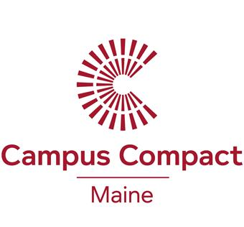

Nomination Form
Community Partner of the Year Award
Community Organization:
Contact Name:
Address:
Phone:
Email:

Nomination Essay: (Should be 2 pages in length.)

- A description of the campus/community partnership;
- How the community partner has helped to enrich student learning;
- How the community partner has positively influenced the community;
- How the community partner has exceeded expectations; and
  - An innovative approach to building or enhancing campus-based efforts to address community isssues

___________________________________________________________ ________________________________
Signature of Civic Engagement Representative Date
____________________________________ ____________________
Signature of President Date

Due by March 6, 2019.

